Name: Amina Qadeer

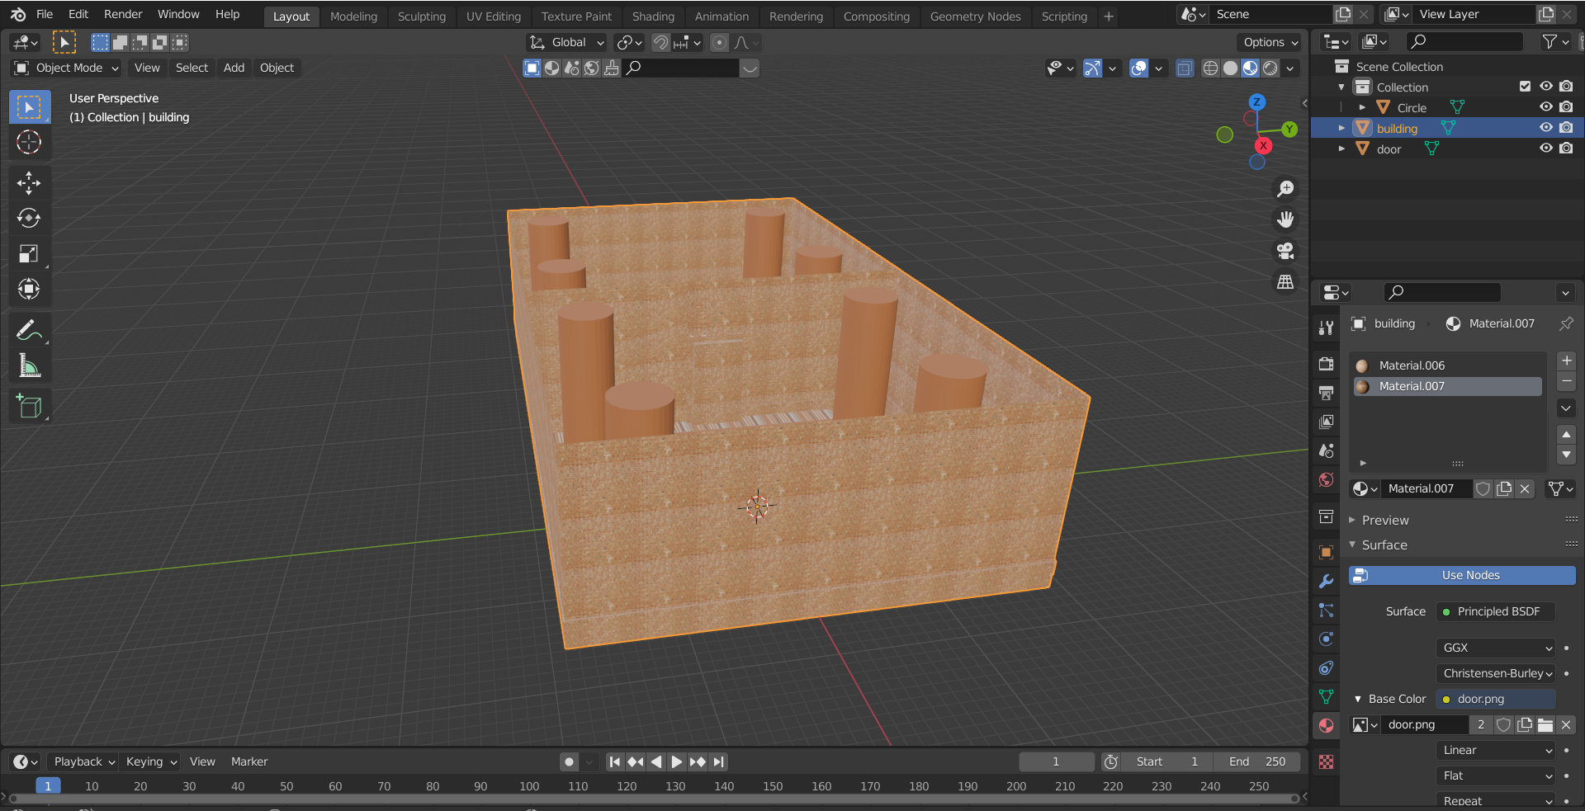

File Import from blender to unity:

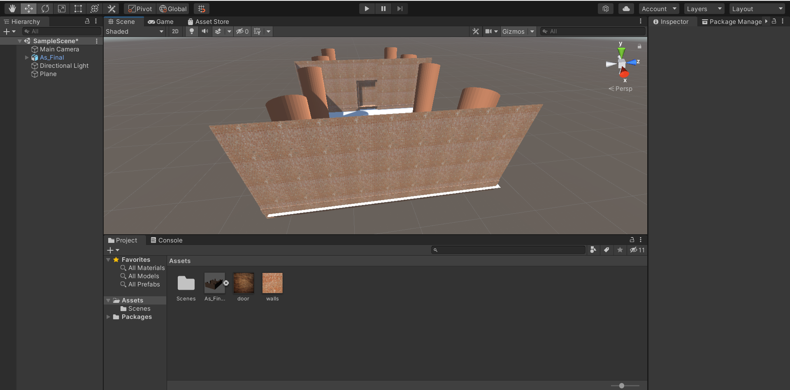

Scripts for moving the capsule and script for destroying the key is added.